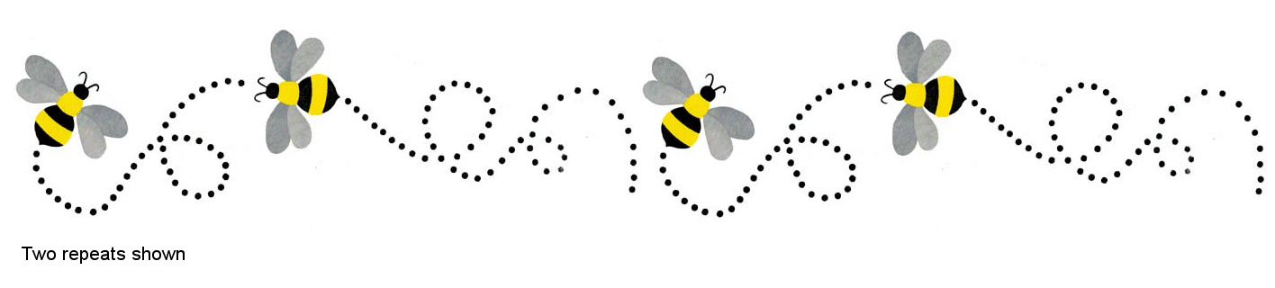

Phoenix Modern Quilt Guild

Vitamin D Quilt Bee 2022

What is it?

Our Vitamin D Bee gives members an opportunity to foster community, make friends, learn, build or solidify skills, try new techniques and experiment with different color combinations. Members are confident in their basic sewing skills and are willing to challenge themselves to try new things! We have had such a great variety of blocks to try from our queens! Each month members take turns being the “Queen Bee” and supplying the other members with a pattern or instructions and materials to complete a quilt block. Traditionally, the members return a completed block at the next month’s meeting. **For now, we will be doing this by mail.**

**To join the 2022 Vitamin D Bee – Notify Francine at:** [**mochawildchild@gmail.com**](mailto:mochawildchild@gmail.com) **by Feb 1. We will start in Feb with packets at the Feb meeting. Please include your name and mailing address and if you have a preferred month to be Queen. The first packets will be mailed in time for February’s meeting. If we have more than 12 members join, we will form 2 groups.**

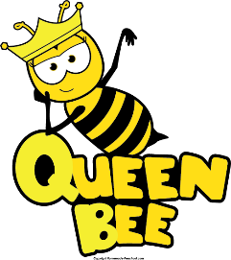

* + Choose a pattern for your bee-mates. The pattern should be **open-source** (free pattern or tutorial) Purchased patterns (including those found online, in books or magazines) may not be copied and distributed without permission from the author. There are MANY free online resources for potential bee blocks. Check out:
    - [Bee Blocks on Pinterest – Just a bit frayed](https://www.pinterest.com/justabitfrayed/bee-block-ideas/)
    - [Moda Bake Shop](https://my.modafabrics.com/categories/moda-bake-shop)
    - [Quilt Block Library](https://www.annemariechany.com/quilt-block-library/) (Gen X Quilters)
    - [Wombat Quilts – Free Paper Piecing Patterns](https://wombatquilts.com/free-paper-piecing-patterns/)
    - [Blossom Heart Quilts – The Bee Hive](http://www.blossomheartquilts.com/2015/01/the-bee-hive-a-quilt-block-tutorial-series/)
    - [42 Quilts](http://www.42quilts.com/p/modern-monday.html)
* Provide enough fabric (plus a little extra to be safe) for your block. Depending on the pattern, you may want to pre-cut all the pieces.
* Test your block – this helps you define any issues and lets you gauge the time commitment.
* Let members know whether they can add in fabric from their own stash and if you want your scraps returned.
* Make sure to include your contact information in case someone has a question or needs to mail your block.
* Setting clear guidelines for your bee-mates helps reduce stress and will help your partners successfully return to you the block(s) you’re looking for!

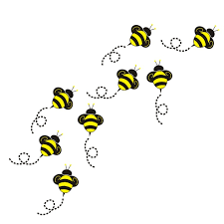

Bee Members

* Start early on your block! It’s perfectly ok to ask your Queen Bee any questions and make them aware of any issues with the pattern or fabric.
  + Leave paper piecing paper in? Return scraps? Add from my own stash?
* Use a ¼” seam allowance unless otherwise instructed.
* Get help from the Queen Bee or your local quilt shop if this is a new or unfamiliar technique.
* “Bee” committed – if you will miss the next meeting, be responsible for mailing or having your completed block delivered and to receive supplies for the following month’s block. Communicate!
* Share! Use #phxmqg #VitaminDBee2022 on Instagram.
* Have fun!