Connector Blocks

Blocks are 10.5 x 10.5 unfinished

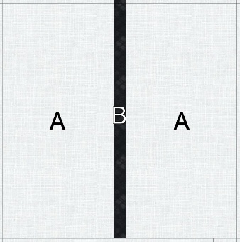

A-Background 10.5 x 5.25 Cut 2

B-Black Fabric 10.5 x 1 Cut 1

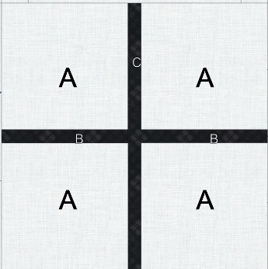

A-Background 5.25 x 5.25 Cut 4

B-Black 5.25 x 1 Cut 2

C-Black 5.25 x 10.5 Cut 1

A-Background 6.5 x 2.5 Cut 4

B-Background 1.5 x 1.5 Cut 16

C-Background 2.5 x 2.5 Cut 4

C-Black 2.5 x 2.5 Cut 1

B-Black 1.5 x 1.5 Cut 16

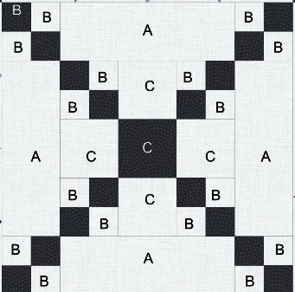

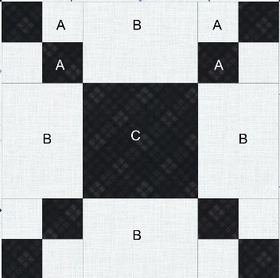

A-Background 2 x 2 Cut 8

B-Background 4.5 x 3.5 Cut 4

C-Black 4.5 x 4.5 Cut 1

A-Black 2 x 2 Cut 8

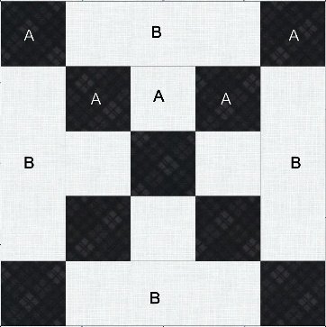

A-Background 2.5 x 2.5 Cut 4

B-Background 2.5 x 6.5 Cut 4

A-Black 2.5 x 2.5 Cut 9

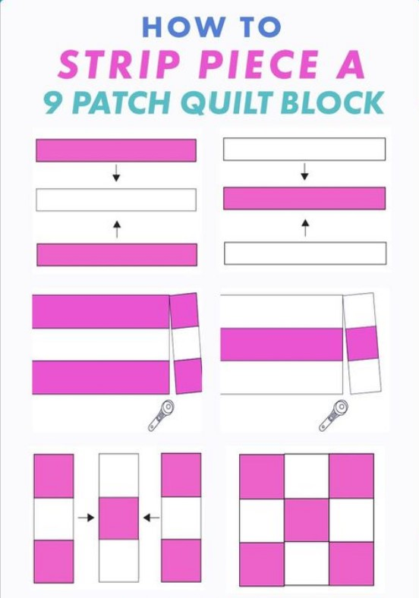

Measurements for the patches are given for each block. Several of the blocks can be made more easily with strip piecing.

If you prefer strip piecing, use the given measurements to cut a strip of each color, sew the strips together then cross cut the strips into the correct unit size.

For example, to strip piece the 4-patch unit in the third connector block cut a 1.5 inch width of fabric strip of the background and the black fabric. Sew the strips together. Cut the strip into 1.5 inch patches. Use the patches in the correct orientation to make the 4-patch unit.