Medallion Block

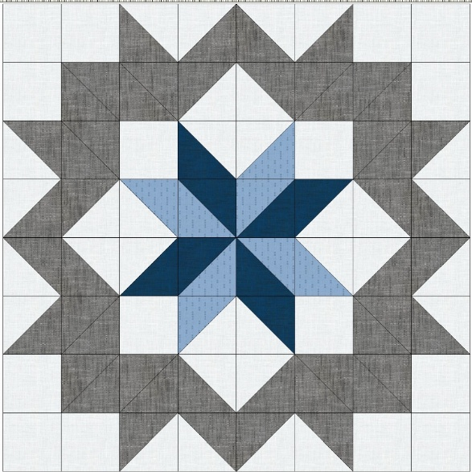 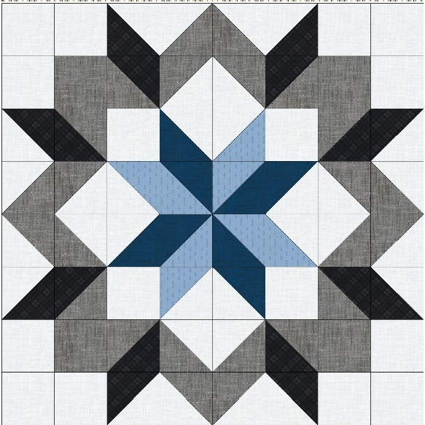

This Carpentar Star block is made up entirely of 4.5 inch (unfinished) Half Square Triangles (HST) and plain 4.5 inch (Unfinished) blocks. Color placement makes the interesting design.

To make the HST units use the following method. Not only do you make two at once, you also avoid sewing on the bias.

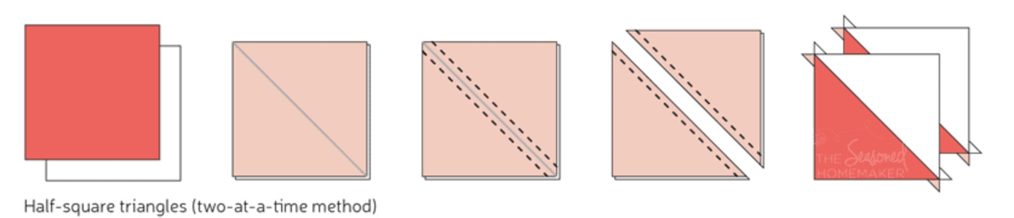

If you use this method, because this units finish at 4 inches, cut the squares at 5 inches. I like to use the block loc ruler to trim the HST’s to the correct size. For this block trim units to 4.5”.

Because of the “Choose Your Own Adventure” aspect of this quilt you will need to count the number of plain units and HST units with your particular color scheme. Just as an example the following units are needed for the 4 color example above.

**Plain units:**

Cut 16-4.5” background squares

Cut 4-4.5” gray squares

Cut **5 inch squares** to make the following HST

Dark blue-4

Light blue-4

Black-8

Background-16

4-HST Dark blue/background

4HST Dark blue/light blue

4 HST Light blue/background

8 HST Black/Background

8 HST Black/gray

16 HST Gray/Background

The unfinished size of the medallion block should be 32.5 x 32.5.

Next add a 4.5” x 32.5” sashing piece to opposite sides of the block.

Add a 4.5 x 40.5 sashing piece to the top and bottom of the block.

Now you will have a 40.5 x 40.5 medallion which will fit nicely in the center of the quilt!

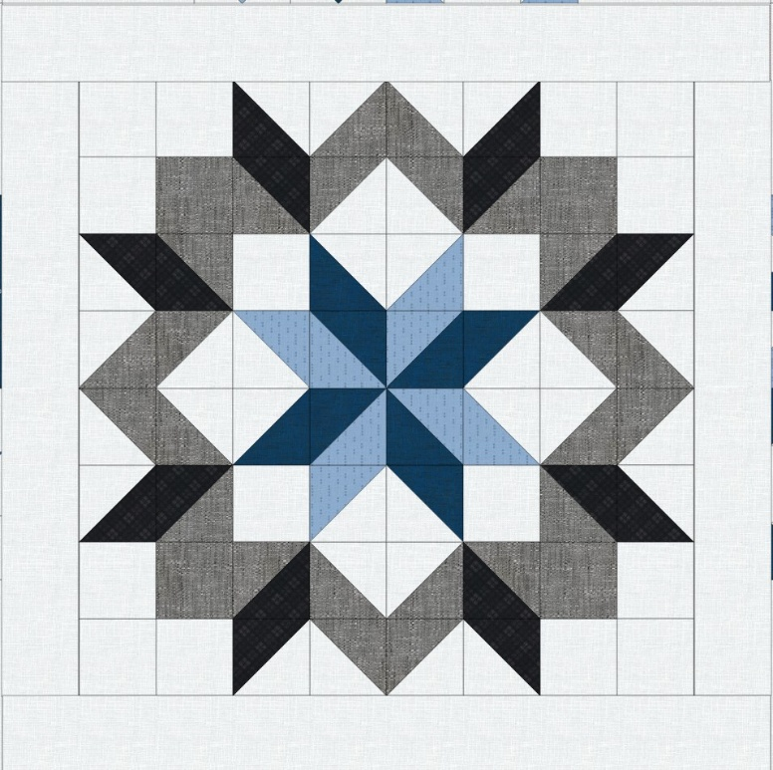

If you want to see a fun video of making a Carpentar Star into an entire quilt, you can check out this episode of The Midnight Quilt Show on You Tube.

[Carpenter Star Quilt Tutorial | Midnight Quilt Show SEASON 3 PREMIERE with Angela Walters](https://www.youtube.com/watch?v=zQsOXAf5kzo&t=300s)