April Block

The April block is the Mayflower block found in the EQ8 library. Although it has its roots in traditional quilts, it is often used in modern quilts but better known as the X block.

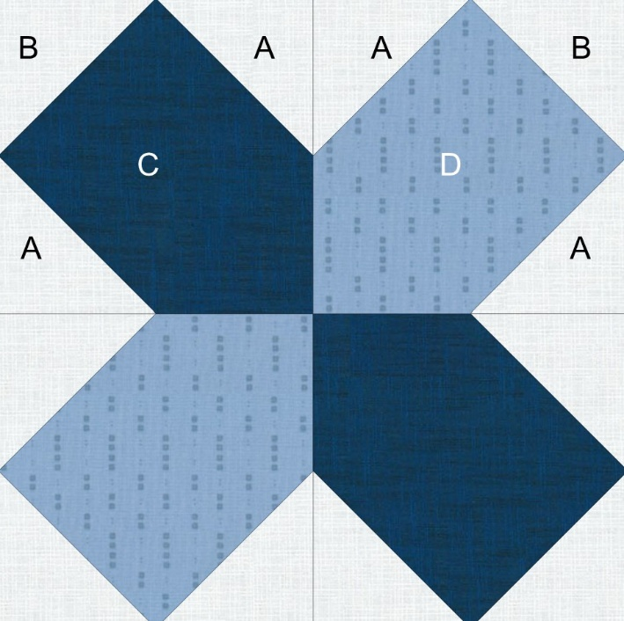

Unfinished size is 10.5 x 10.5

Cutting Directions:

A-Background 3.5 x 3.5 Cut 8

B- Background 3 x 3 Cut 4

C-Dark fabric 5.5 x 5.5 Cut 2

D-Light fabric 5.5 x 5.5 Cut 2

Sewing Directions:

1. Draw a light line or use a Hera marker to make a diagonal line on the back of each background square. Both A and B squares.
2. Place an A background square on the corner of a C square. Sew on the diagonal line.

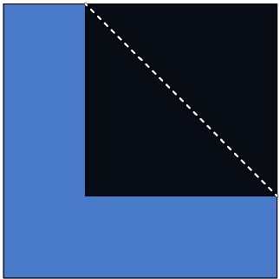

1. Place another A square in the **opposite** corner and sew on the diagonal line. Trim seam allowance to ¼ inch and press seams towards the dark fabric. Make 2 identical patches.



1. Place a B square on a corner and sew on the diagonal line. Trim seam allowance and press towards the background fabric.
2. Make two identical patches.



1. Follow steps 1-5 using the lighter fabric. This time press seams to the background fabric. Make two identical patches.
2. Layout patches as seen above. Seams will nest. Sew top two patches, then bottom two patches pressing center seam to the darker fabric. Sew the center seam joining the top and bottom patches to form the 10.5 x 10.5 block.